
Project Title: [Online Quiz Platform]
CMPE314 – SOFTWARE ENGINEERING

PROJECT PROPOSAL
Submitted To: Asst. Prof. Dr. Felix Babalola
Group Number: 1
Submitted By:
[Tinotenda Mupati] - [22202963]
[Lamine Diamoutene] - [22301016]
[Mahisa Ahadi] - [22213656]
[Christy lumbidi] - [22215889]
[Jaciara Faif] - [22304137]

Date of Submission: 03/17/2026
1. INTRODUCTION
1.1. Project Background
Usually, instructors must arrange quizzes by looking for empty classes and finding invigilators, although this is a small challenge. However, for bigger challenges, we can mention that in many cases number of students registered for a course is too much, and examining all the papers in a limited time is difficult, or in cases like corona virus period or other Campus closure , students cannot take the classical exam.

1.2. Problem Statement
There is no online system where students can take their exams, see their grade immediately, and help instructors with evaluating students.

1.3. Project Aim
To develop a web based online quiz platform for creating and taking quizzes. This platform must give the teachers the ability to build quizzes with various question types , and students can take them and receive immediate scores and feedback.

2. PROPOSED SOLUTION
2.1. Description of the System
The system is a web application with two interfaces: one for the instructors and one for students. Using system teachers can create, manage, and publish quizzes with multiple question types (multiple choice, true/false, short answer, fill in the blank, and so on).
Students can securely log in, take quizzes within a set time limit, and submit their answers online.
The system automatically grades objective questions and provides scores instantly.

2.2. Key Features (High-Level)
- Feature 1: User Registration and Authentication
- Feature 2: Quiz Creation & Management
- Feature 3: Automatic Grading
- Feature 4: Result Storage & Analytics
- Feature 5: Quiz Security
- Feature 6: Dashboard Interface

3. STAKEHOLDERS AND TARGET USERS
3.1. Primary Users
- [Student]: (Needs to have a secure exam and see their results instantly).
- [Teachers]: (Needs to manage exams, save time and be able to create quizzes easily).

3.2. Secondary Stakeholders
- [e.g., System Administrator]: Manages user permissions and system backups.
- [e.g., University Administrators]: Needs to Approve and manage system usage ,monitor overall performance and reports, ensure compliance with academic policies.

4. REQUIREMENT HIGHLIGHTS
ID | Requirement Description | Priority (High/Med/Low)
FR-01 | The system shall allow teachers and students to create accounts and log in securely | High
FR-02 | The system shall give roles (teacher/student) with different permissions. | High
FR-03 | The system shall allow teachers to create, edit, and delete quizzes. | High
FR-04 | The system shall allow students to view available quizzes and submit answers within the allowed time | High
FR-05 | The system shall automatically grade questions and calculate total scores | High
FR-06 | The system shall save quiz results and keep student history. | High
FR-07 | The system shall allow teachers to set time limits, start dates, and deadlines. | Medium
FR-08 | The system shall support multiple question types (MCQ, True/False, Short Answer) and allow teachers to add, edit, or remove questions | Medium

5. TECHNOLOGY STACK
[Specify the technologies you plan to use and why.]
Layer | Technology Choice | Justification
Frontend (UI) | [NextJS, TRPC + Tanstack Query and TailwindCss] | [Next.js is a powerful web framework; it is the recommended way to create React projects and provides useful features like file-based routing, image optimization, server actions, and works perfectly fine with React server components. It is also the most popular framework, so it has a huge community and better support. Trpc+Tanstack: Since we are using a decoupled architecture (backend + frontend), I need a type-safe API to efficiently communicate with the backend without having to define the types myself. Tanstack query is the industry standard for data fetching. It provides auto-retry, amazing error handling, and caching. As well as powerful revalidation features and mutations that are a lot more powerful than NextJS ' default Server Actions  TailwindCSS because improves development speed and maintainability. It is powerful, brings in its own design system, which saves a lot of time, and it removes the need to manage different CSS files.]
Backend (Logic) | [Node.js] | [It lets you use the same language for both frontend and backend, which keeps development simpler.]
Database | [MySQL] | [It is a widely used relational database management system that provides efficient storage and retrieval of structured data. It supports relationships between entities such as users, quizzes, and results, making it suitable for the Online Quiz Platform. In simple terms It supports relational data, handles large numbers of users, fast and reliable and it works well with web applications  And also, it integrate smoothly with the stacks that Christy and Lamine are using
Version Control | [e.g., Git / GitHub] | For collaboration and code backup.
Open Source Libraries | [e.g., Bootstrap, Chart.js] | To speed up development.

6. PROJECT PLAN AND TIMELINE
6.1. Task Breakdown & Gantt Chart
Phase | Week | Activities | Deliverable
Phase 1: Requirements Analysis | Week 1–2 | Requirements gathering, stakeholder analysis, use case modeling | SRS Draft
Phase 2: System Design | Week 3–4 | System architecture design, database design, UML diagrams, UI/UX prototyping | Complete Design Models
Phase 3: Development Setup & Implementation | Week 5–6 | Environment setup, frontend development, backend development | Working Prototype
Phase 4: Integration & Testing | Week 7 | API integration, unit testing, integration testing | Tested System
Phase 5: Finalization & Delivery | Week 8 | Bug fixing, deployment, documentation, final preparation | Final Report & Presentation

Gantt Chart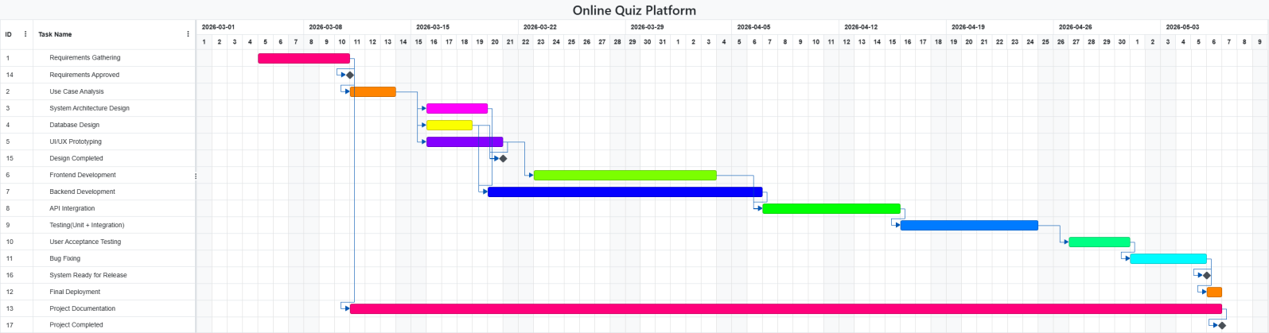

6.2. Team Responsibilities
Team Member | Primary Responsibility
[Jaciara Faif] | Requirements & Use Case modeling
[Tinotenda Mupati] | Class Diagram & Database Design
[Lamine Diamoutene] | UI Design & Frontend Development
[Christy lumbidi] | Backend Logic & Testing
[Mahisa Ahadi] | Documentation & Project Coordination

7. CONCLUSION
This platform is worth pursuing because it makes the process of creating, administering and grading quizzes easier. It also helps us with faster and more accurate evaluation. Overall , the platform supports remote education and can significantly improve the assessment process in modern education systems.

